DID WE LAND ON THE MOON?

Grupa

1. INTRODUCTION:
Since the ancient times, people have wanted to travel to other worlds. One of the most mysterious and desirable locations seemed to be the moon. From ancient myths to more recent novels, as those written by Jules Verne, the moon has always been a special destination, the closest alien world to our home, a place from where people could see how small and insignificant they are compared to the Universe and how fragile the Earth is.
The Apollo program was a NASA spaceflight endeavor that landed the first humans on Earth's moon. Conceived during the presidency of Dwight D. Eisenhower, Apollo began in earnest after US President John F. Kennedy announced his support for a manned moon landing on May 25, 1961, as part of a special address to a joint session of Congress:
“ ... I believe that this nation should commit itself to achieving the goal, before this decade is out, of landing a man on the Moon and returning him safely to the Earth. No single space project in this period will be more impressive to mankind, or more important in the long-range exploration of space; and none will be so difficult or expensive to accomplish. ”
Kennedy's goal was accomplished during the Apollo 11 mission on July 20, 1969 with the landing of astronauts Neil Armstrong and Buzz Aldrin, while Michael Collins remained in lunar orbit. Five subsequent Apollo missions also landed astronauts on the Moon, the last in December 1972. In these six Apollo spaceflights twelve men walked on the Moon. These are the only times humans have landed on another celestial body.

2. THEORY:

Various Moon landing conspiracy theories claim that some or all elements of the Apollo Project and the associated Moon landings were falsifications staged by NASA and members of other involved organizations Some of the more notable of these various claims include allegations that the Apollo astronauts did not set foot on the Moon; that NASA and others intentionally deceived the public into believing the landings did occur by manufacturing, destroying, or tampering with evidence, including photos, telemetry tapes, transmissions, and rock samples; and that the deception continues to this day. Such claims are common to most of the conspiracy theories.
The most predominant idea is that the entire human landing program was a complete hoax from start to finish. Some claim that the technology to send men to the Moon was insufficient or that the Van Allen radiation belts, solar flares, solar wind, coronal mass ejections, and cosmic rays made such a trip impossible. However, another variant on this is the idea that NASA and its contractors did not recover quickly enough from the Apollo 1 fire, and so all the early Apollo missions were faked, with Apollo 14 or 15 being the first authentic mission. There are many hoax hypotheses, each of which addresses a specific aspect of the Moon landing, coming from multiple sources, while the ‘real landing’ hypothesis is a single story. This variation is considered a key indicator that the hoax hypothesis actually constitutes a conspiracy theory. These theories present many evidences that show the landing as being fake, the most important being photographic evidences.
In the following there will be presented some of the most important evidences of the conspiracy theories and their official explanation given by NASA or observed in some experiments that replicate parts of the Moon missions.
Besides problems like the lack of technology, space radiation, apparently fake lunar rocks, missing tapes and blueprints for the Apollo Lunar Module, Lunar rover, most of the evidences of the conspirators against lunar landing are based on photographic evidence and mistakes that are revealed by these.
To begin with, the conspirators claim that the lunar landing is fake because:
1. In some pictures appears o problem: the crosshairs appear to be behind objects.
• Explanation: Overexposure causes white objects to bleed into the black areas on the film.

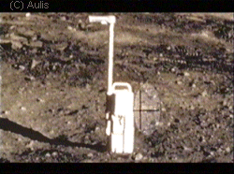 | 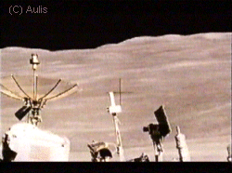

2. There are no stars in any of the photos. The Apollo 11 astronauts also claimed in a press conference after the event to have not remembered seeing any of the stars.
• Explanation: The sun was shining. Cameras were set for daylight exposure, and could not detect the faint points of light. Even the brightest stars are dim and difficult to see in the daytime on the Moon. Neil Armstrong said that he could not see stars on the daylight side of the Moon with his naked eyes.
3. The quality of the photographs is implausibly high.
• Explanation: There are many poor quality photographs taken by the Apollo astronauts. NASA chose to publish only the best examples. The Apollo astronauts used high resolution 70mm professional cameras and film.
4. Identical backgrounds in photos which, according to their captions, were taken miles apart.
• Explanation: Shots were not identical, just similar. Background objects were mountains many miles away. Without an atmosphere to obscure distant objects, it can be difficult to tell the relative distance and scale of lunar features.
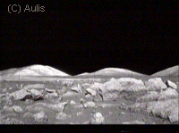 | 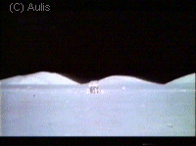
5. Some of the photos contain artifacts like the two seemingly matching 'C's on a rock. There is also a 'C' on the ground in front of the rock. The use of the letter C on film props is well known by the people in Hollywood and is used to show where the centre of the scene should be.
• Explanation: The "C"-shaped image was from printing imperfections, not in the original film from the camera.
6. Footprints in the extraordinarily fine lunar dust, with no moisture or atmosphere or strong gravity, are unexpectedly well preserved, in the minds of some observers – as if made in wet sand.
•Explanation: The dust is silicate, and this has a special property in a vacuum of sticking together like that. The astronauts described it as being like "talcum powder or wet sand". This theory was demonstrated to be unsubstantiated on the MythBusters episode "NASA Moon Landing"

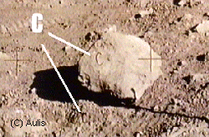  Rock with letter “C” | 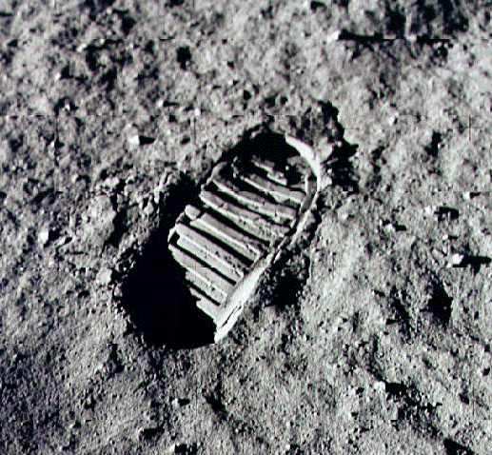  Footprint
7. The flag placed on the surface by the astronauts flapped despite there being no wind on the Moon
•Explanation: The astronauts were moving the flag into position. Without air drag, these movements caused the free corner of the flag to swing like a pendulum for some time. A horizontal rod, visible in many photographs, extended from the top of the flagpole to hold the flag out for proper display. The flag's rippled appearance was from folding during storage, and it could be mistaken for motion in a still photograph. The top support rod telescoped and the crew of Apollo 11 could not fully extend it. Later crews preferred to only partially extend the rod. Videotapes show that when the flag stops after the astronauts let it go, it remains motionless. At one point the flag remains completely motionless for well over thirty minutes.
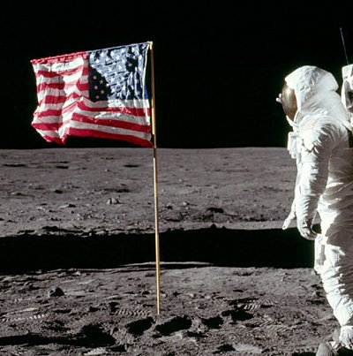  Cropped photo of Buzz Aldrin saluting the flag (note the fingers of Aldrin's right hand can be seen behind his helmet). | 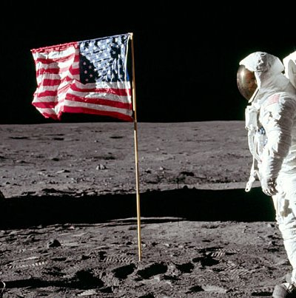  Cropped photo taken a few seconds later, Buzz Aldrin's hand is down, head turned toward the camera, the flag is unchanged.
8. Some problems appear in this photo of Aldrin taken by Armstrong:
8.1 While studying Neil's famous portrait of Buzz - seen above on the cover of NASA SP-350 - Journal Contributor Joonas Helminen noticed that there seemed to be no sign of the OPS antenna.
•Explanation: The Media Services version has been cropped on the bottom and sides and a black region has been added at the top. A careful examination of a detail from 5903 reveals the bottom centimeter or so of the OPS antenna. Clearly, although a black area was added at the top of prints released for publication, no attempt was made to draw in an antenna.
8.2 The horizon is about 89 degrees from the true vertical. Dr Groves has worked out that after analysing the shadows cast by both the astronaut in the picture and the supposed cameraman in the visor, that Armstrong who is taking the picture is standing on ground that is a mere few inches higher than where Aldrin is stood, If this is the case, then it means that whoever took the shot was in fact at least 2 feet higher than Aldrin and therefore means that Armstrong, although visible with the camera in the visor, is not the actual person who took the shot.
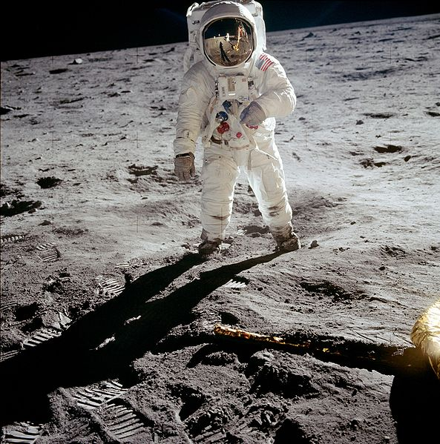 | 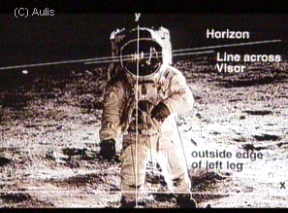

9. Mechanical problem revealed from photos: No blast crater or any sign of dust scatter as was seen in the 16 mm movies of each landing.
•Explanation: No crater should be expected. The Descent Propulsion System was throttled very far down during the final landing. The Lunar Module was no longer rapidly decelerating, so the descent engine only had to support the module's own weight, diminished by the 1/6 g lunar gravity and by the near exhaustion of the descent propellants. At landing, the engine thrust divided by the nozzle exit area is only about 10 kilopascals (1.5 PSI). Beyond the engine nozzle, the plume spreads and the pressure drops very rapidly. (In comparison the Saturn V F-1 first stage engines produced 3.2 MPa (459 PSI) at the mouth of the nozzle.)
10. The film of the astronauts moonwalking is actually film of the astronauts skipping in front of a high-framerate camera, slowing down the picture and giving the illusion they are on the Moon.
•Explanation: While the HBO Mini-series "From the Earth to the Moon", and a scene from the movie "Apollo 13" used the sound-stage and harness setup, it is clearly seen from those films that dust kicked up did not quickly settle (some dust briefly formed clouds). In the film footage from the Apollo missions, dust kicked up by the astronauts' boots and the wheels of the lunar rovers shot up quite high (due to the lunar gravity), and settled immediately to the surface in an uninterrupted parabolic arc (due to there being no air to support the dust). Even if there had been a sound stage for hoax Moon landings that had had the air pumped out, the dust would have reached nowhere near the height and trajectory as the dust shown in the Apollo film footage because of terrestrial gravity.
11. The second stage of the launch rocket and / or the Lunar Module ascent stage produced no visible flame.
•Explanation: The Lunar Module used Aerozine 50 (fuel) and dinitrogen tetroxide (oxidizer) propellants, chosen for simplicity and reliability; they ignite hypergolically –upon contact– without the need for a spark. These propellants produce a nearly transparent exhaust.
12. The astronauts could not have survived the trip because of exposure to radiation from the Van Allen radiation belt and galactic ambient radiation.
•Explanation: The spacecraft moved through the belts in about four hours, and the astronauts were protected from the ionizing radiation by the aluminium hulls of the spacecraft. In addition, the orbital transfer trajectory from the Earth to the Moon through the belts was selected to minimize radiation exposure. Even Dr. James Van Allen, the discoverer of the Van Allen radiation belts, rebutted the claims that radiation levels were too dangerous for the Apollo missions. Plait cited an average dose of less than 1 rem, which is equivalent to the ambient radiation received by living at sea level for three years.
3. EXPERIMENT:
Most of the problems regarding the moon landings have been recently tested in MythBusters Episode 104: NASA Moon Landing. All the myths saying that the landing was fake were busted. They have even sent a laser beam on one of the reflecting surfaces left by the astronauts on the Moon and received the signal back. However, some people might say that these results are biased because NASA equipment has been used.
4. CONCLUSION:
Taking everything into consideration, the hoax theories about the landing seem to be false. Almost all the evidences raised by conspirators are proved to be false. In my opinion, there would have been harder to make a fake landing than to actually land, especially because of the Cold War and the competition between U.S. and the Soviet Union. The Russians had the equipment to monitor the Apollo missions. So, if the landing was indeed fake, the Russians had to be involved as well, and this is quite impossible, considering the diplomatic relations between the countries at that time. I believe that the moon landing was the greatest engineering realization of the last century, and the people who worked to achieve this goal should be respected not falsely accused.

- BIBLIOGRAPHY:
- http://www.hq.nasa.gov/alsj/a11/a11-5903history.html
- The documentary “Conspiracy Theory: Did We Land on the Moon?(2001)”
- http://www.badastronomy.com/bad/tv/iangoddard/moon01.htm
- http://en.wikipedia.org/wiki/Moon_landing_conspiracies
- http://en.wikipedia.org/wiki/Apollo_program
- http://www.ufos-aliens.co.uk/cosmicapollo.html
- MythBusters Episode 104: NASA Moon Landing;

